Amazon Rekognition
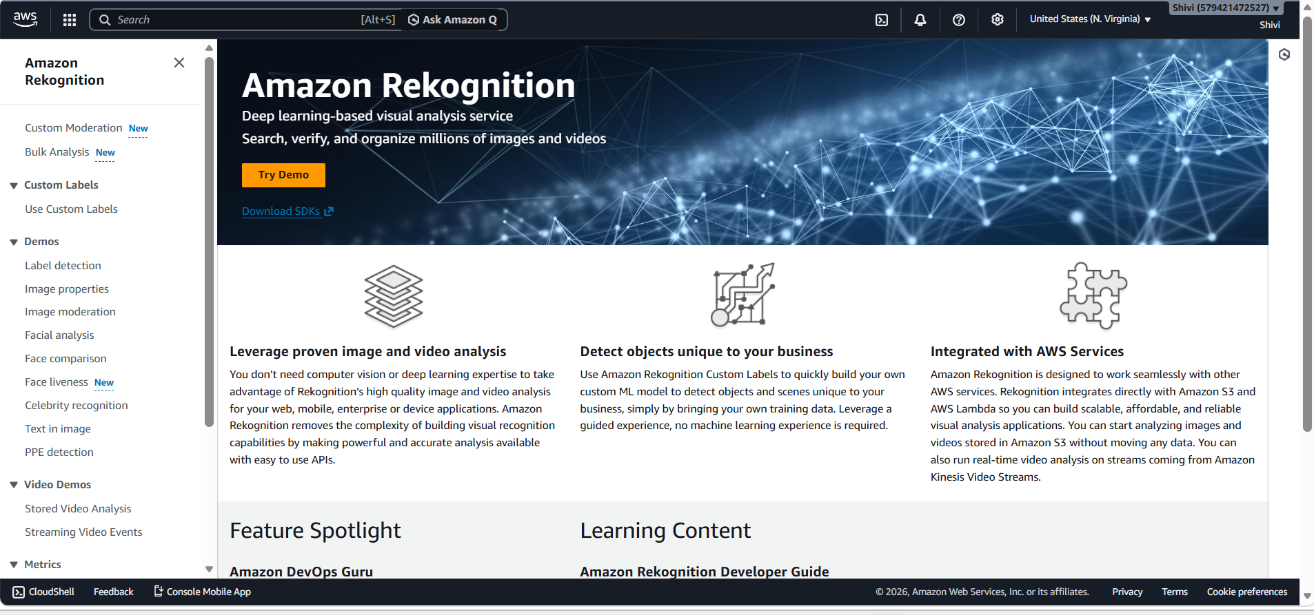

Demos--
Label Detection: To automatically identify and classify thousands of objects, scenes, concepts, and actions in images and videos, returning each detected label.

Example 1 –

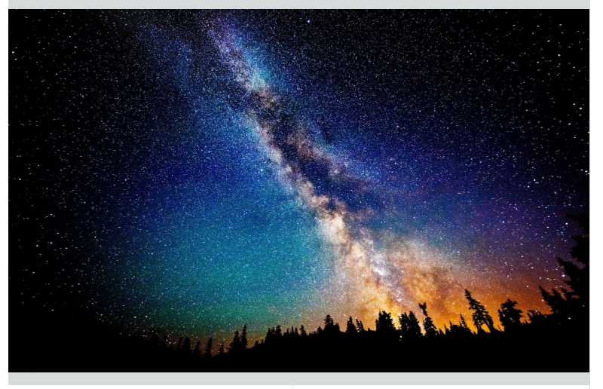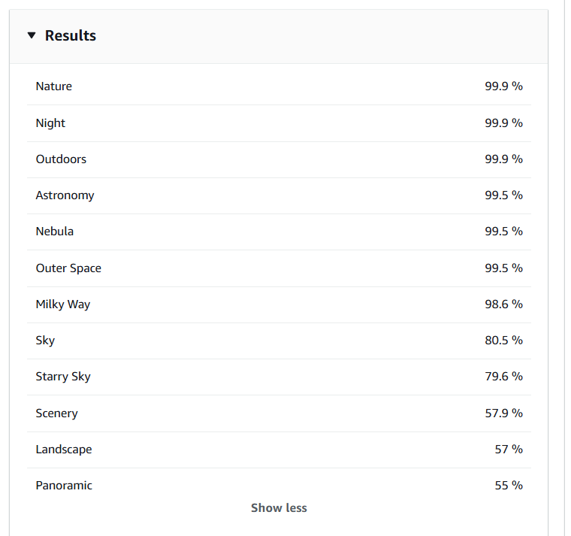

Example 2 –

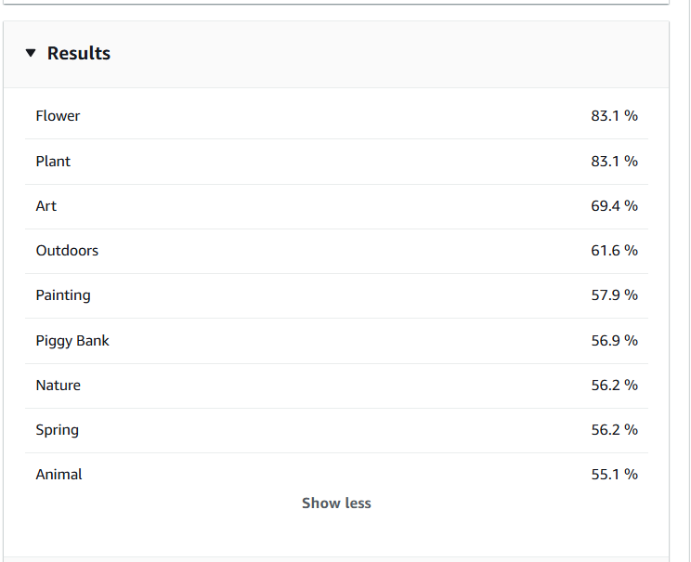

Image Properties: To analyze the visual properties of an image such as dominant colors, image quality, sharpness, brightness, and contrast.

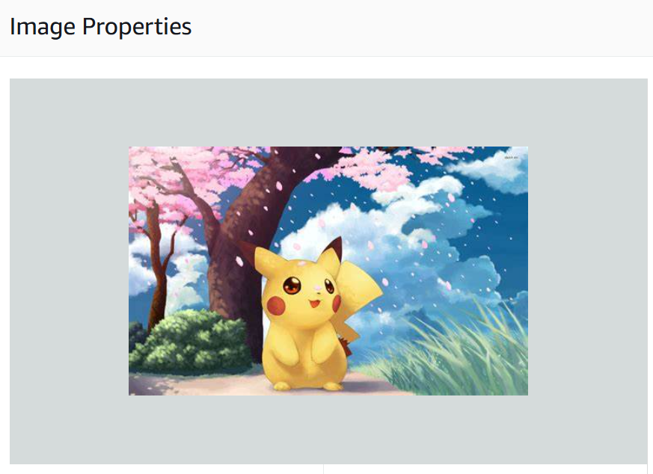
Example 1-
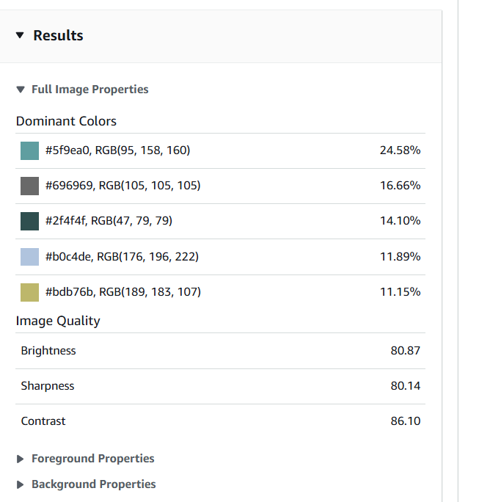

Example 2-
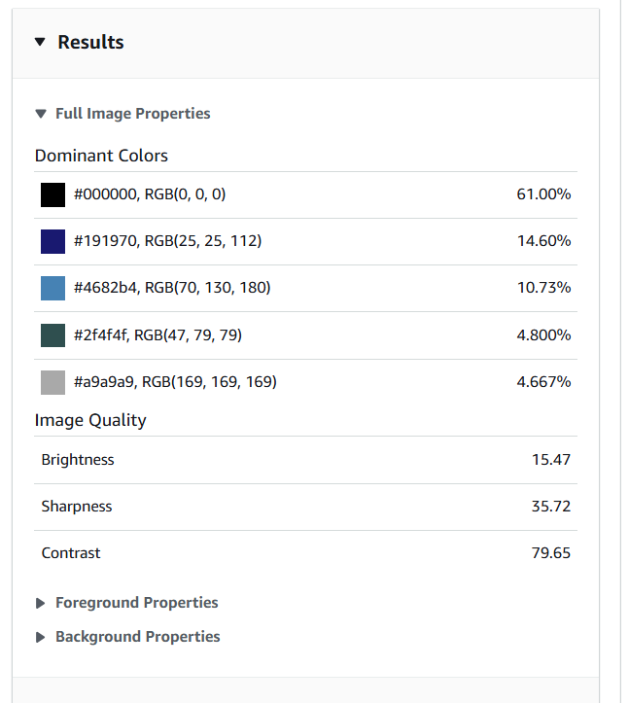
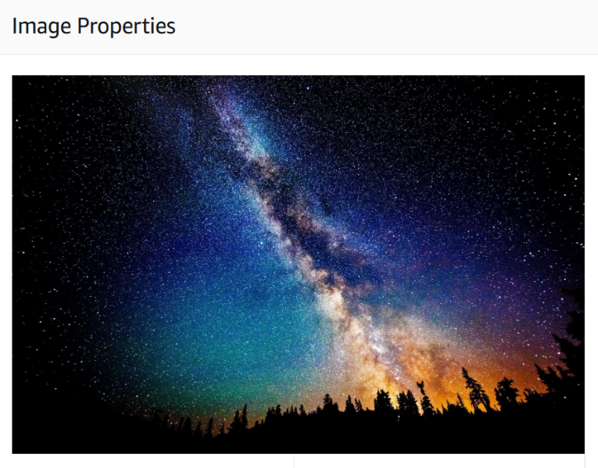

Image Moderation: To detect inappropriate, explicit, or unsafe content in images and videos, enabling platforms to enforce community guidelines and protect users automatically.
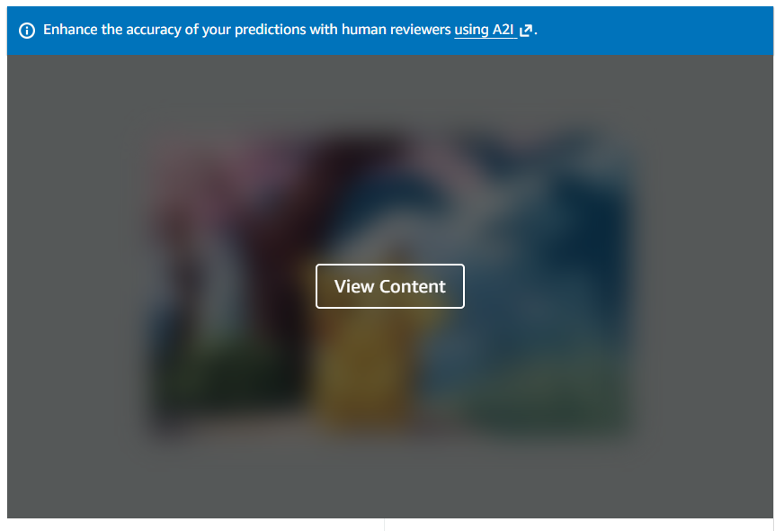
Example 1-
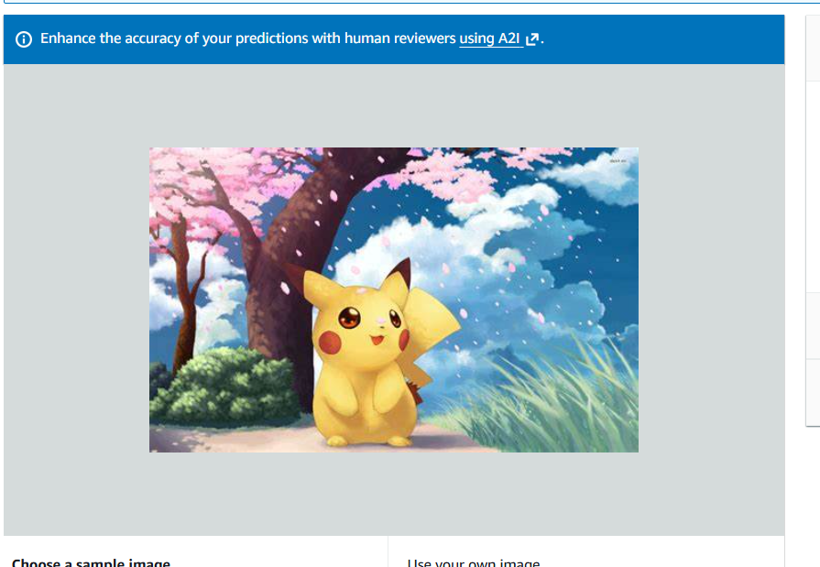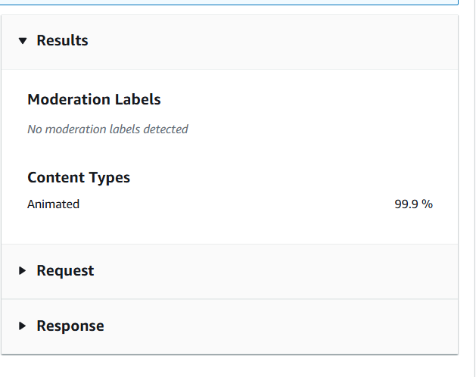

Example 2-
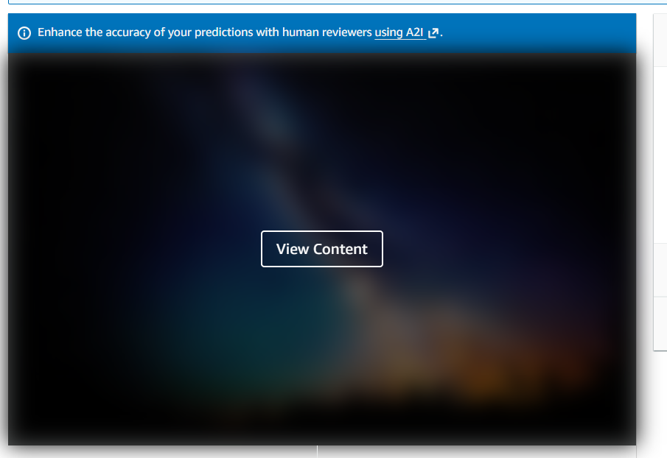
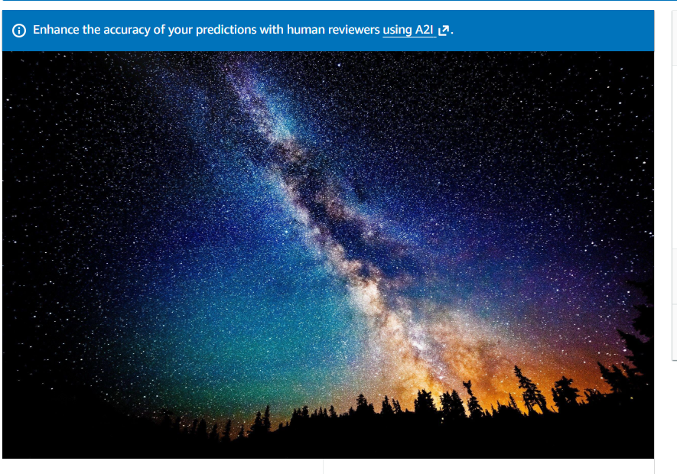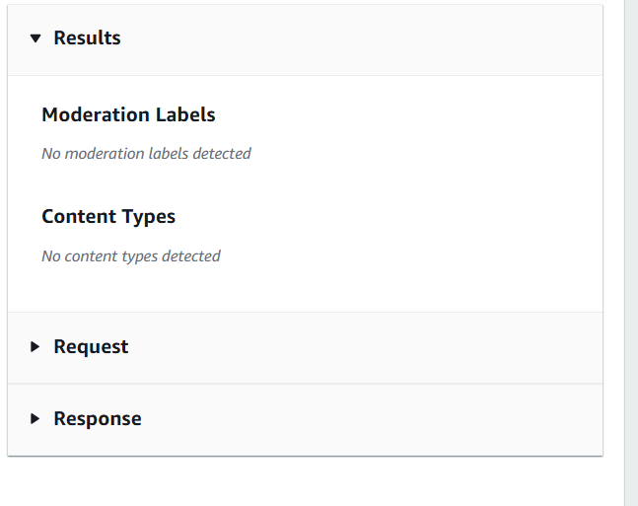

Facial Analysis: To detect faces in images and videos and analyze facial attributes including estimated age range, gender, emotions, facial hair, eye glasses, and face pose.

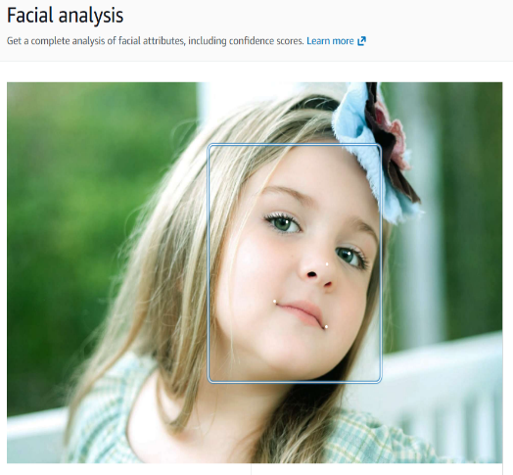
Example 1-
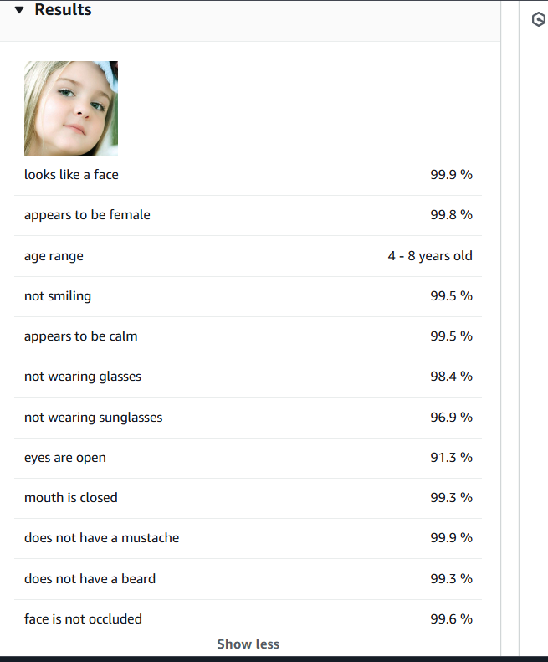
Example 2-
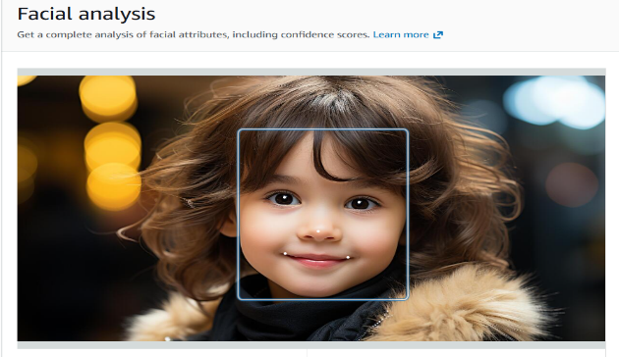
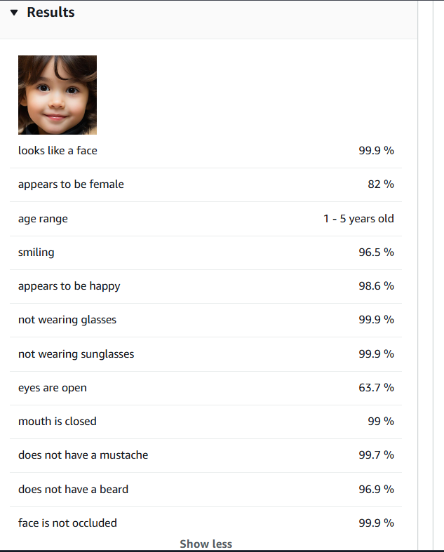
Face Comparison: To compare a face in one image against faces in another image or a collection, returning a similarity score to verify or match identities.

Example 1-
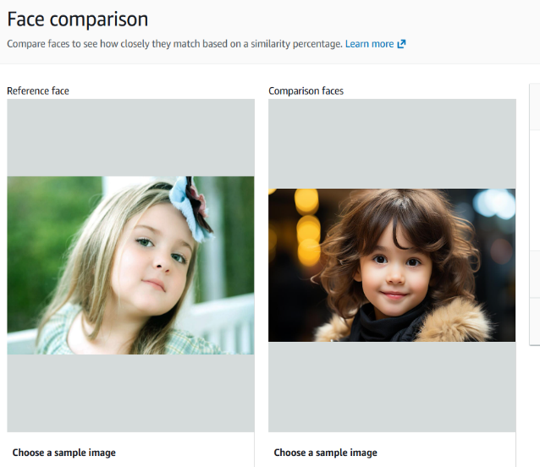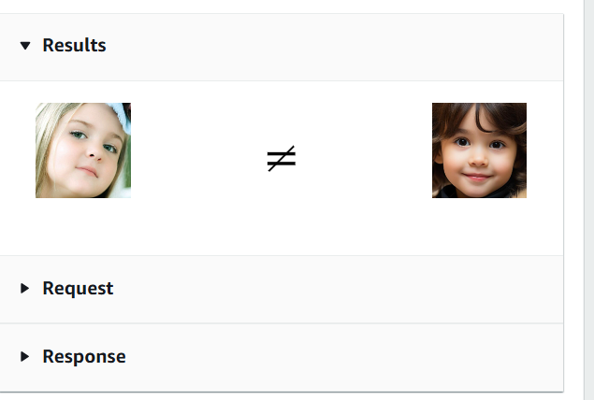

Example 2-
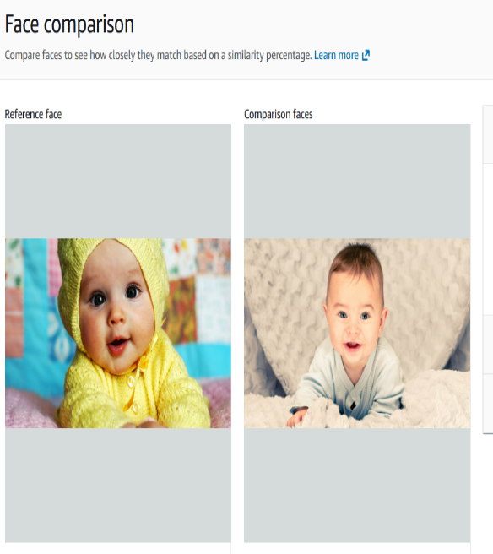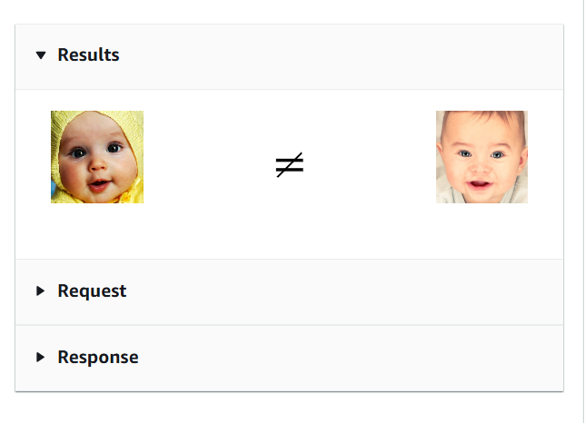

Face Liveness: To determine whether a face in a selfie or video stream belongs to a real, physically present person or is a spoof (photo, video replay, or mask), supporting secure authentication flows.
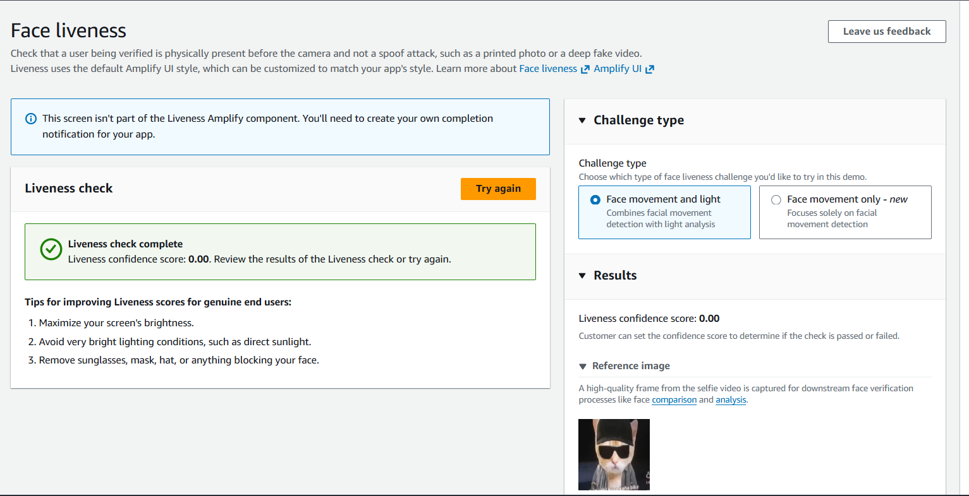

Celebrity Recognition: To identify thousands of well-known celebrities in images and videos, returning the celebrity name, face bounding box, and a match confidence score.

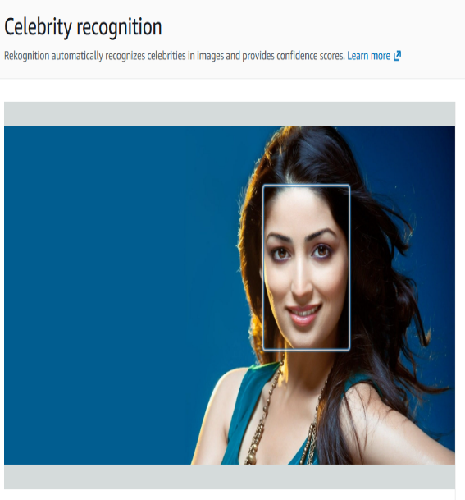
Example 1-
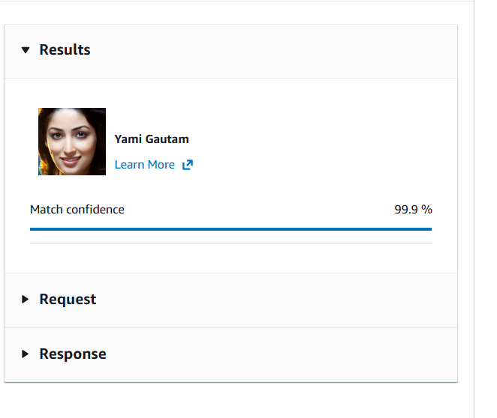

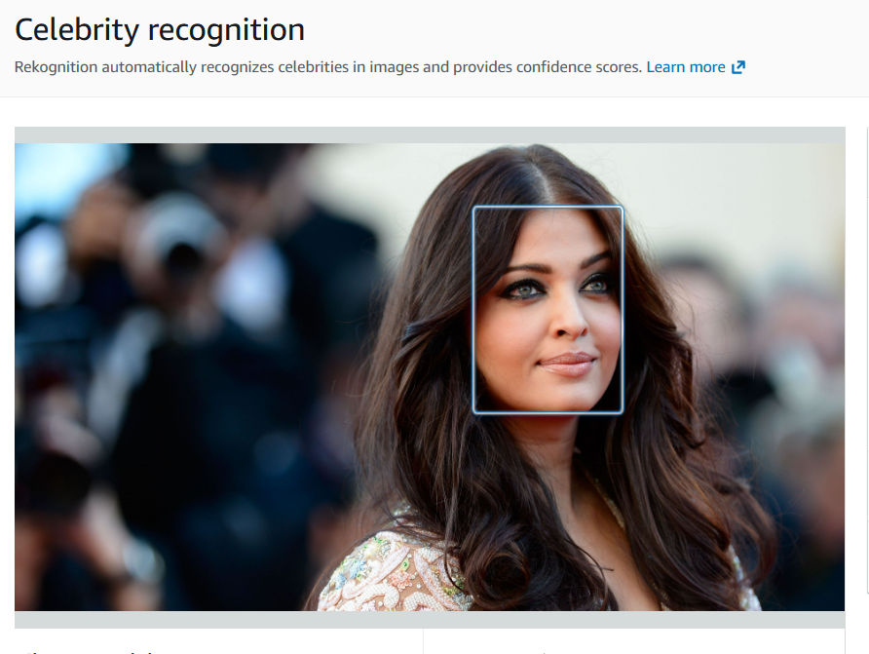
Example 2-
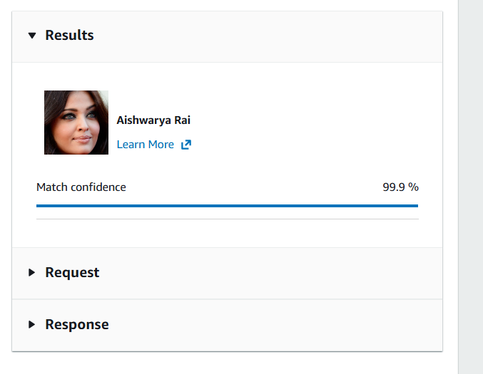

Text in Image: To detect and extract printed and handwritten text (OCR) from images and video frames, enabling use cases like license plate reading, document digitization, and sign recognition.

Example 1-
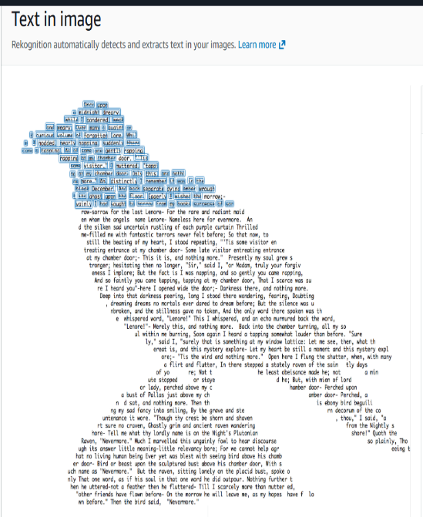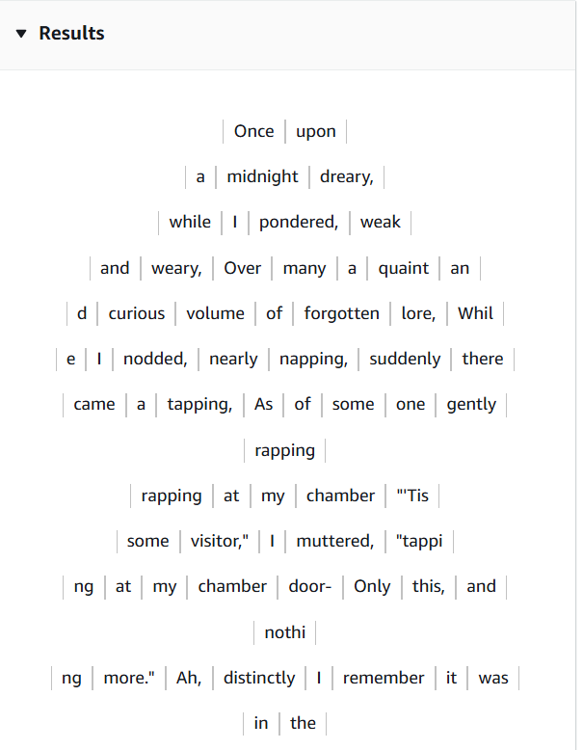
Example 2-
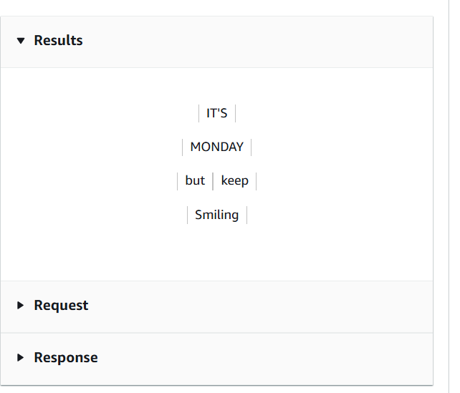
PPE Detection: To identify personal protective equipment (such as helmets, face covers, and hand covers) worn by persons in images.

Example 1-
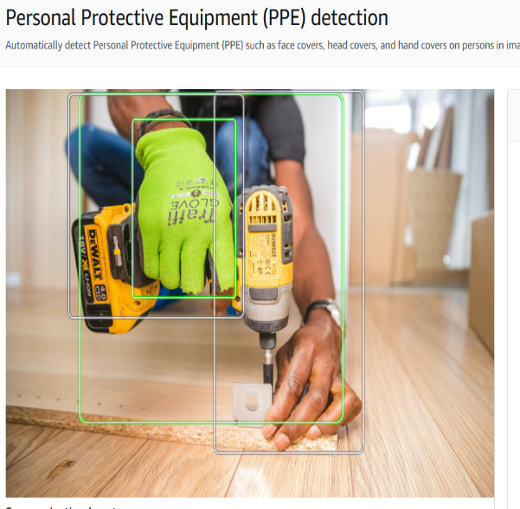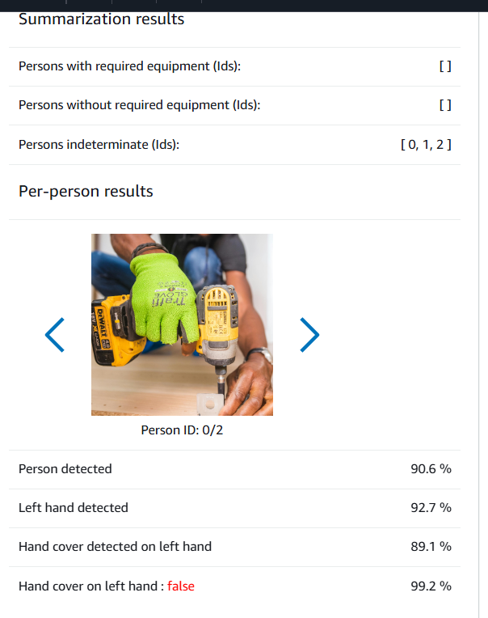

Example 2-
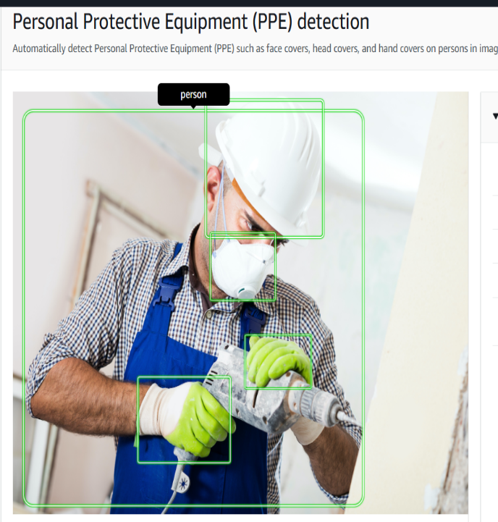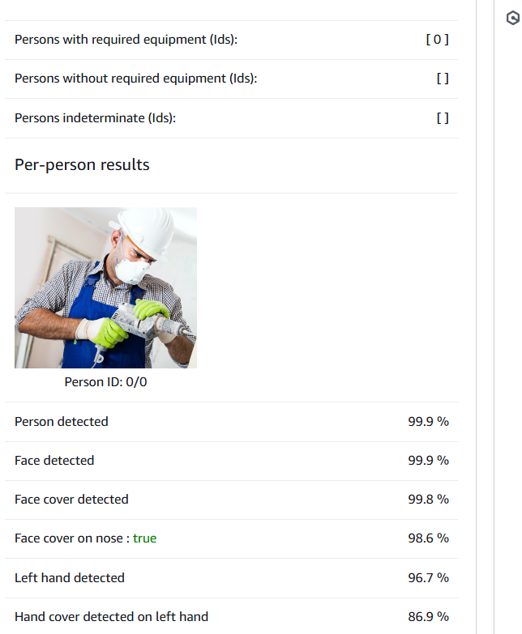

Video Demos--
Stored Video Analysis: Upload a video and let Rekognition analyze it to find faces, objects, or text in it
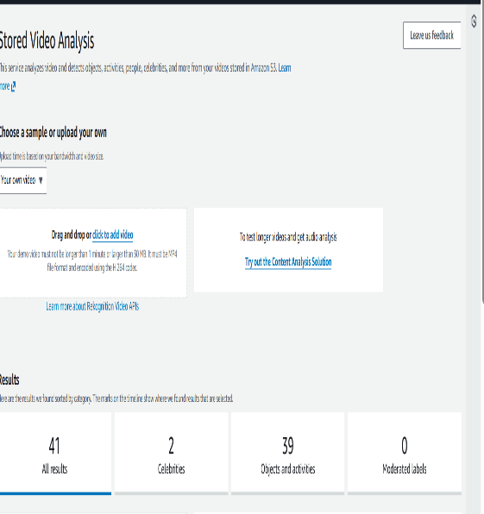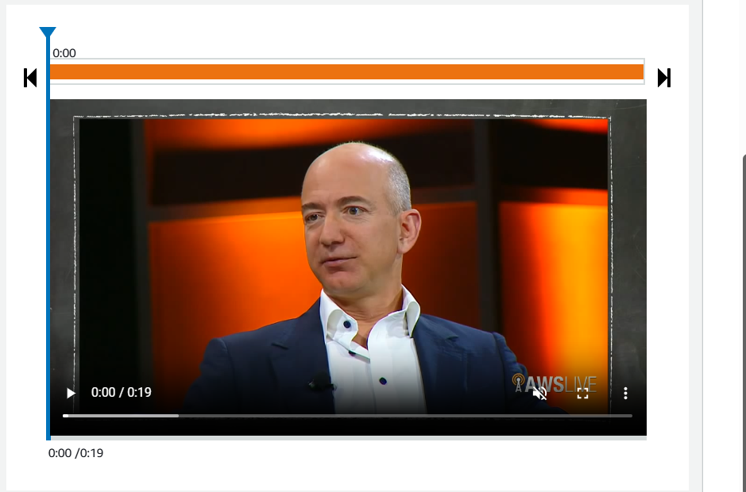
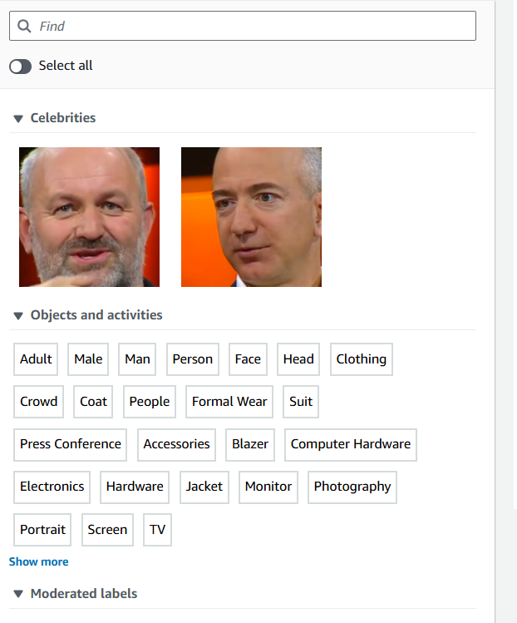

Streaming Video Events: Analyze a live video feed in real time and get instant alerts when something is detected.

